[ Insert official UPAEP logo ]
UPAEP · Decanato de Ingenierías
EVIDENCE — US25-T1
Define the device registry model
SmartGreenAI: Cilantro Crop

1. Task information
Task ID | US25-T1
User Story | US-25 — Register IoT devices, sensors and actuators
Sprint | Sprint 2 (2026-09-21 – 2026-10-09)
Week | Week 2
Responsible | Alexis Enrique Valle Parra
Peer reviewer | Jorge Velez Delgado
Planned / actual hours | 1 h / 1 h
Completed on | September 29, 2026
Status | Done

2. Task description
Together with Oscar (US-07), define the fields: device (id, name, greenhouse zone, status), sensor (id, device_id, type, unit), actuator (id, device_id, type).

3. Completion conditions
✓ Condition 1: Fields for device, sensor and actuator defined.
How it was verified: Fields defined — device: id, name, greenhouse zone (greenhouse_id + area_id), status (is_active), MAC address, API key hash, firmware, last_seen; sensor: id, device_id, type, unit (plus physical range); actuator: id, device_id, type (plus state).
Registry fields
Entity | Fields
Device | id, name, mac_address, location, greenhouse_id, area_id (zone), is_active (status), api_key_hash, firmware, last_seen
Sensor | id, device_id, area_id, name, type, unit, physical_min, physical_max, is_active
Actuator | id, device_id, area_id, name, type, state, last_update, is_active
1500,7860
✓ Condition 2: Fields included in the shared ER diagram with Oscar.
How it was verified: The fields are part of the shared ER diagram maintained with Oscar (US07-T1).
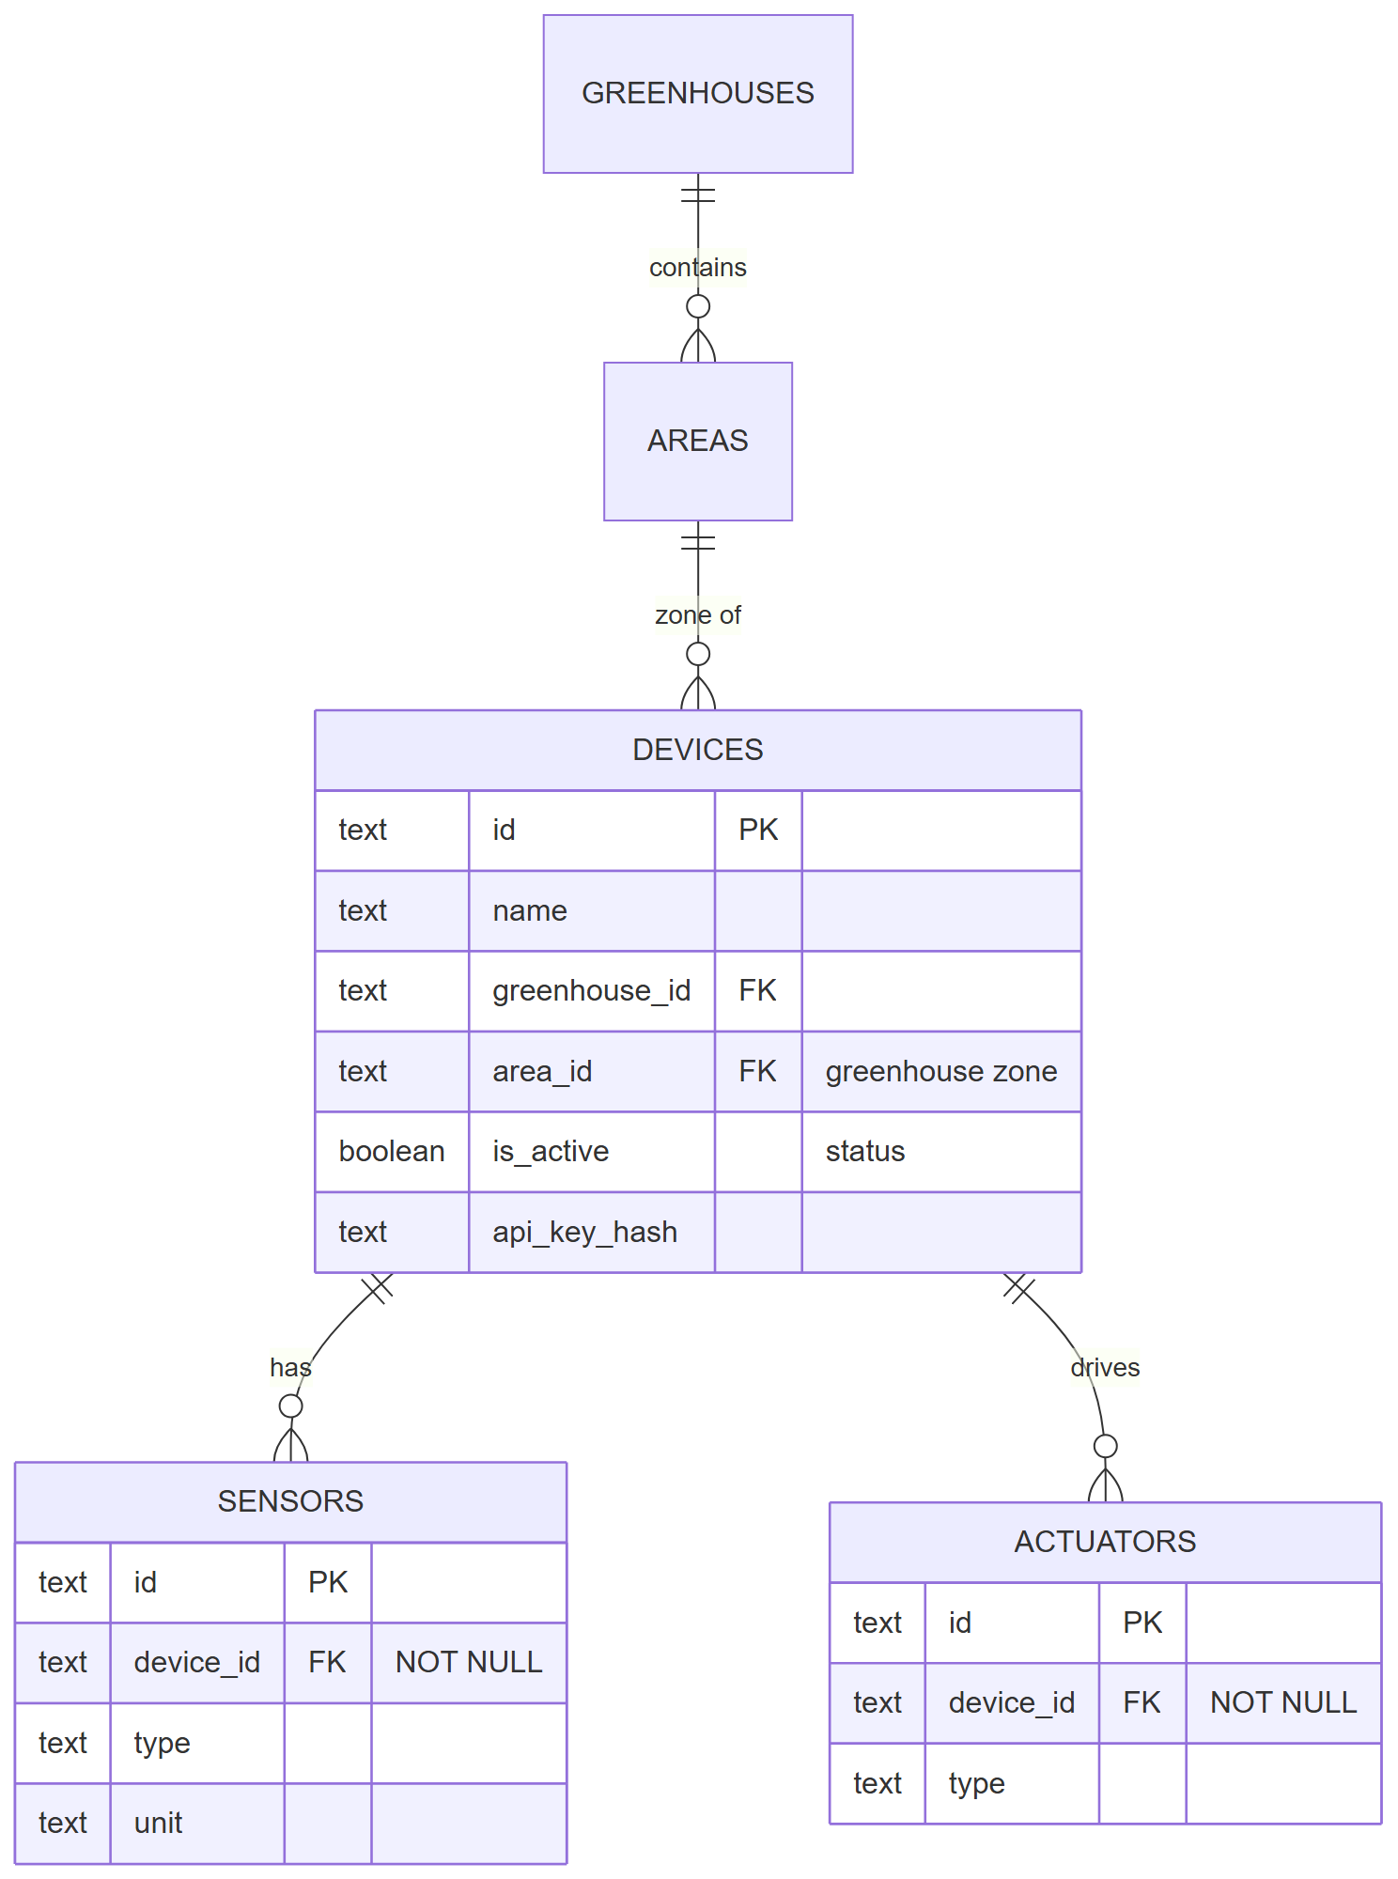
Figure US25-T1-1. Device registry in the shared ER diagram (devices, sensors, actuators linked to a device and a greenhouse zone). (US25-T1_Define_Device_Registry_Model_1.png)
✓ Condition 3: Every sensor/actuator is linked to a device.
How it was verified: Every sensor and actuator is linked to a device: device_id is a NOT NULL foreign key, and no row lacks a device.
Every sensor and actuator references a device (NOT NULL foreign key) (2 rows; US25-T1_Define_Device_Registry_Model_2.csv)
table_name | column_name | is_nullable
sensors | device_id | NO
actuators | device_id | NO
SQL: SELECT table_name, column_name, is_nullable FROM information_schema.columns WHERE table_name IN ('sensors','actuators') AND column_name = 'device_id'
Sensors / actuators without a device (2 rows; US25-T1_Define_Device_Registry_Model_4.csv)
table_name | without_device
sensors | 0
actuators | 0
SQL: SELECT 'sensors' AS table_name, COUNT(*)::int AS without_device FROM sensors WHERE device_id IS NULL UNION ALL SELECT 'actuators', COUNT(*)::int FROM actuators WHERE device_id IS NULL
✓ Condition 4: Evidence: Fields included in the shared ER diagram.
How it was verified: Fields included in the shared ER diagram (Figure 1).

4. Attached files
- US25-T1_Define_Device_Registry_Model_1.png
- US25-T1_Define_Device_Registry_Model_2.csv
- US25-T1_Define_Device_Registry_Model_3.sql
- US25-T1_Define_Device_Registry_Model_4.csv
- US25-T1_Define_Device_Registry_Model_5.sql

5. Traceability
Related requirements | FR-05, FR-06, FR-07, NFR-02, NFR-09
Implementation | See docs/TRACEABILITY.md
Verification | See docs/TRACEABILITY.md

6. Sign-off
Role | Name | Date | Signature
Responsible | Alexis Enrique Valle Parra | September 29, 2026
Peer reviewer | Jorge Velez Delgado | September 29, 2026
Product Owner acceptance | Alexis Enrique Valle Parra | September 29, 2026
Approval record: Daily Meeting 3 of Sprint 2 (Monday, October 5, 2026), team update: Alexis Enrique Valle Parra — "US25-T1 to US25-T4 finished"; Daily Meeting 2 recorded that US25-T1 would be finished on Tuesday together with Oscar.

